James Dryden, 993083613

Abilio Oliveira, 999550263

Homestay Application

Requirements:

* At the top level, our application asks the user to sign in, or to sign up.
* When a profile is created, the user chooses to create either a student or host account, and from then on, when they sign in, their options are specific to the type of account they created.
* The administrator will have a separate account, and will sign in as Admin.
* The administrator options will also be displayed accordingly when he or she logs in.
* When a student logs in, they are presented with three options: Manual Selection, Placement Wizard, and Manage Profile.
* When Manual Selection is launched, filter options are displayed. The student first enters his or her desired time frame, and then may filter by distance to campus, pets, etc.
* Once the filters are set, the student chooses to submit. A list of hosts is then displayed according to those filters.
* The student can select any of the displayed hosts, which then displays all public information.
* The student can go back to filter results, or the student can choose to make a request to this host. This creates a request item between the student and host.
* When a student chooses the Placement Wizard, priority options are displayed.
* For every category, the student can change the priority, which by default is always set to the lowest priority.
* When the student is finished, they can choose submit, which will then show them a list of hosts, ranked by relevance to the students information and priority choices.
* As with Manual Selection, they now have the choice to create requests with certain hosts.
* Both students and hosts may choose to manage their profile after logging in. When this option is chosen, all the profile information is displayed, and the user may change any field, and then choose to save or quit.
* The host only has one other option, which is to review requests. When this is chosen, the host is shown a list of active requests.
* These requests show public information about the student interested in staying with that host.
* The host may then choose to either accept or reject the students’ request.
* If it is rejected, the request is deleted, and the student may not make a request with that host for 30 days.
* If the request is accepted, this request is put in a list of pending requests.
* When the administrator logs in, they are presented with a list of pending requests.
* The administrator may choose to review the next request in line.
* The public information of the associated host and student are displayed, and the administrator may choose to accept or reject this pairing.
* If the request is rejected, the student and host are notified, and again, the student may not make a request with this host for 30 days.
* If the request is accepted, a meeting is arranged between the student and host, and both parties are notified.

Use Case Diagram:

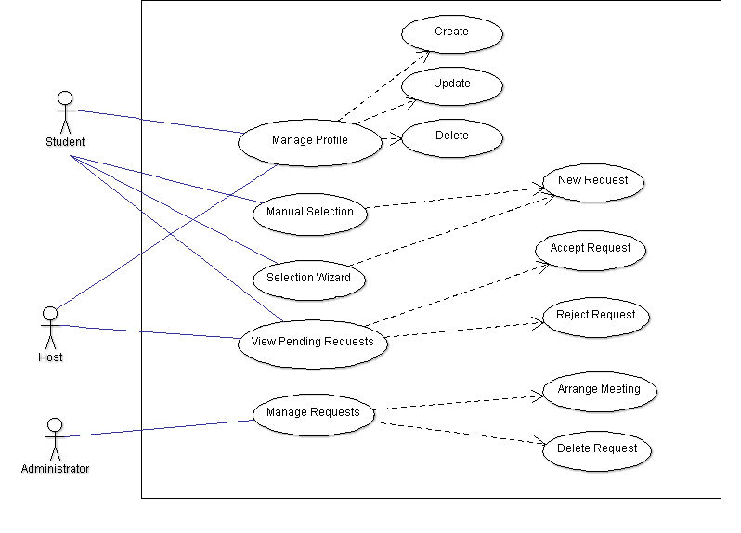

Class Diagram

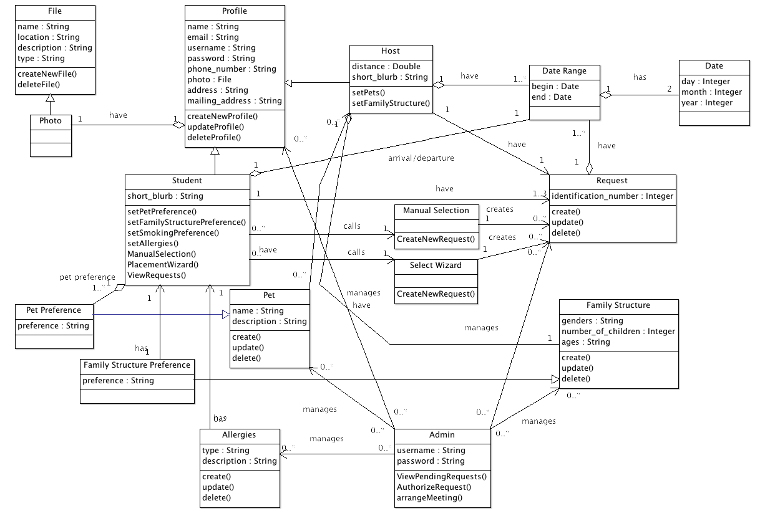

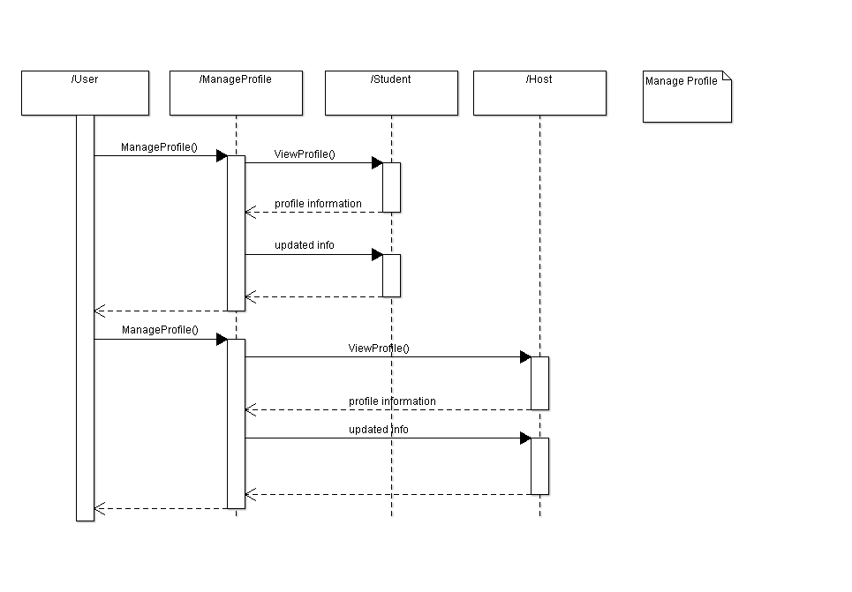 Sequence Diagrams:

Manage Profile

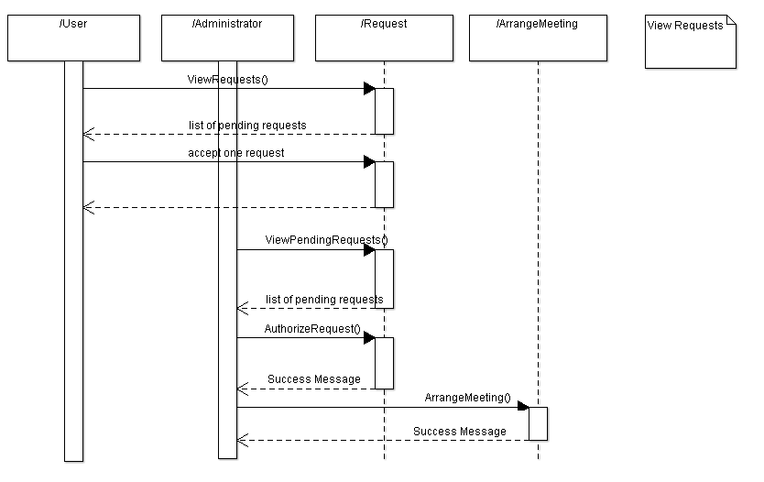View Requests

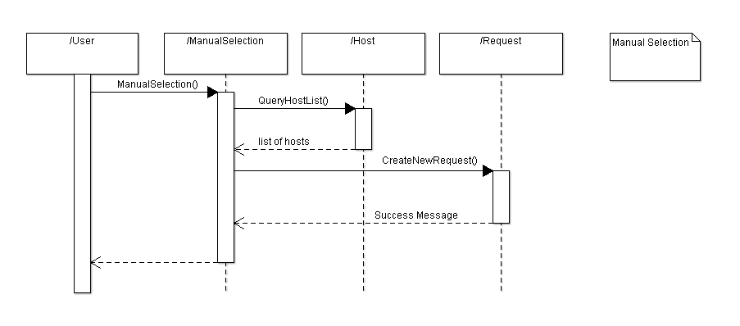 Manual Selection

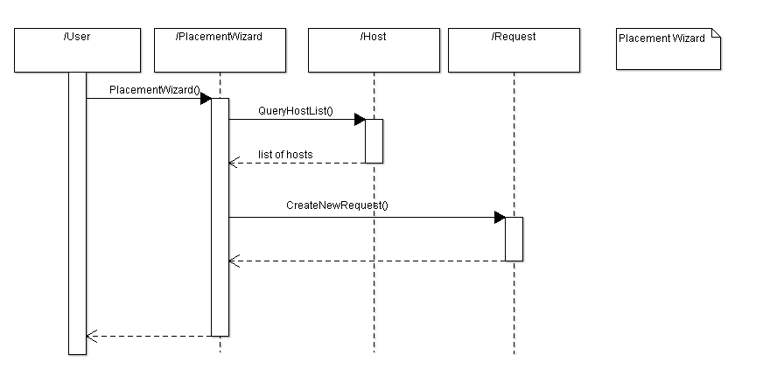Placement Wizard

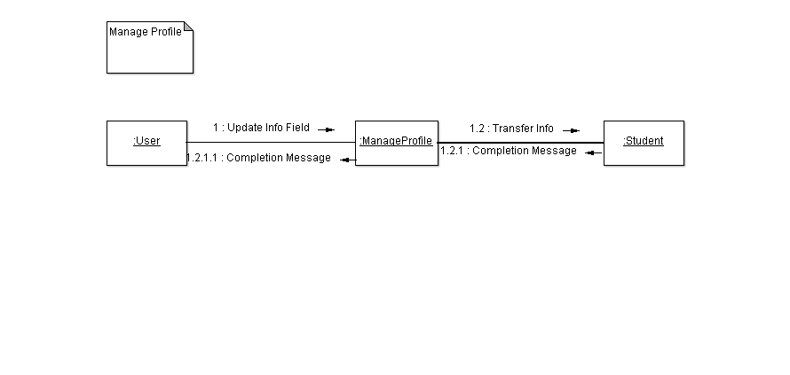 Collaboration Diagrams

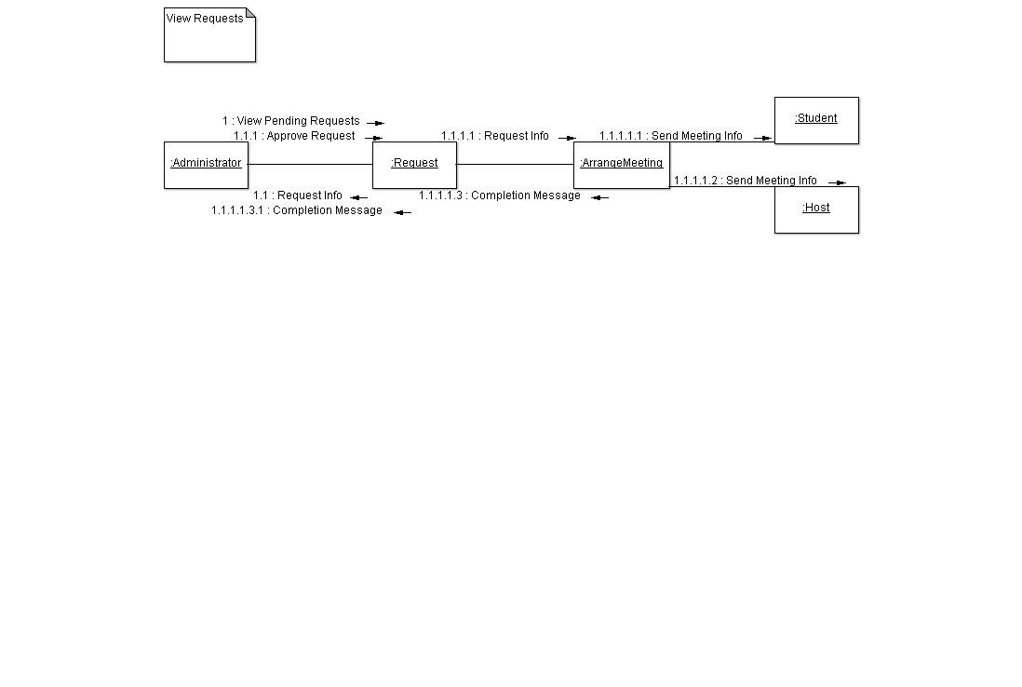

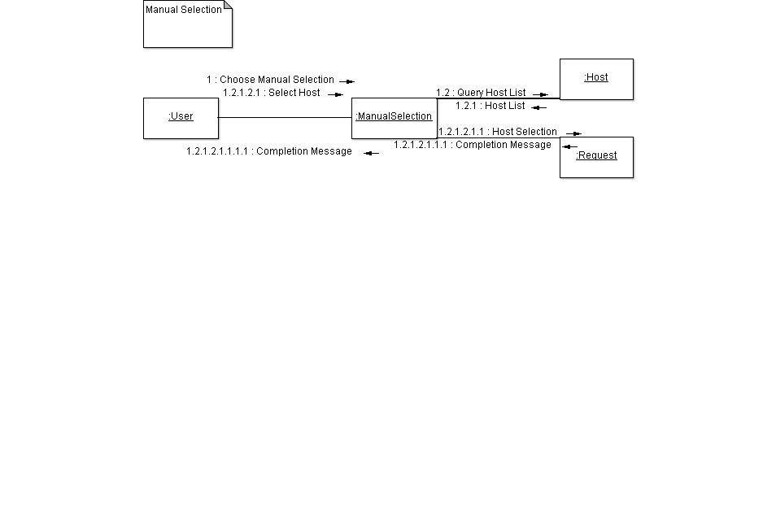

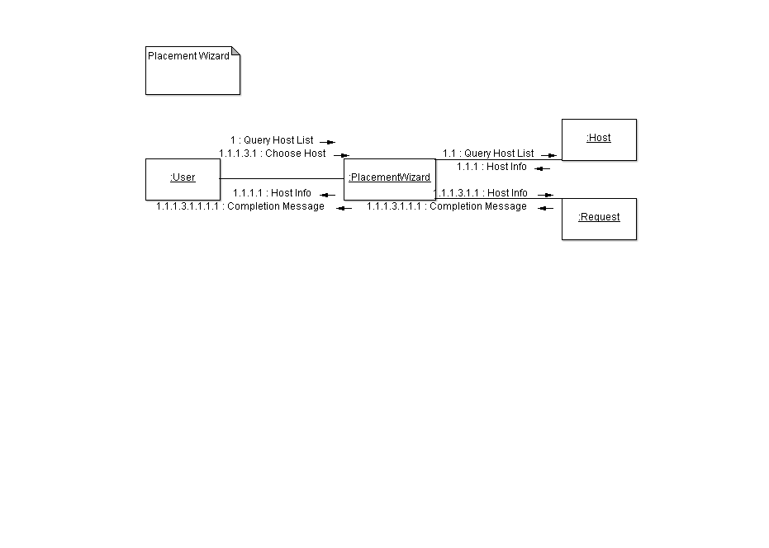

State Charts

